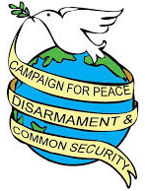
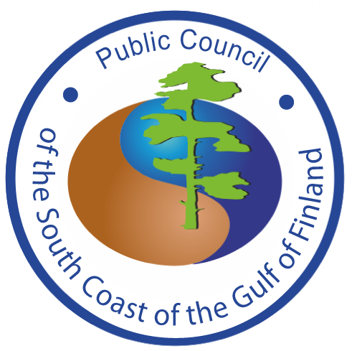
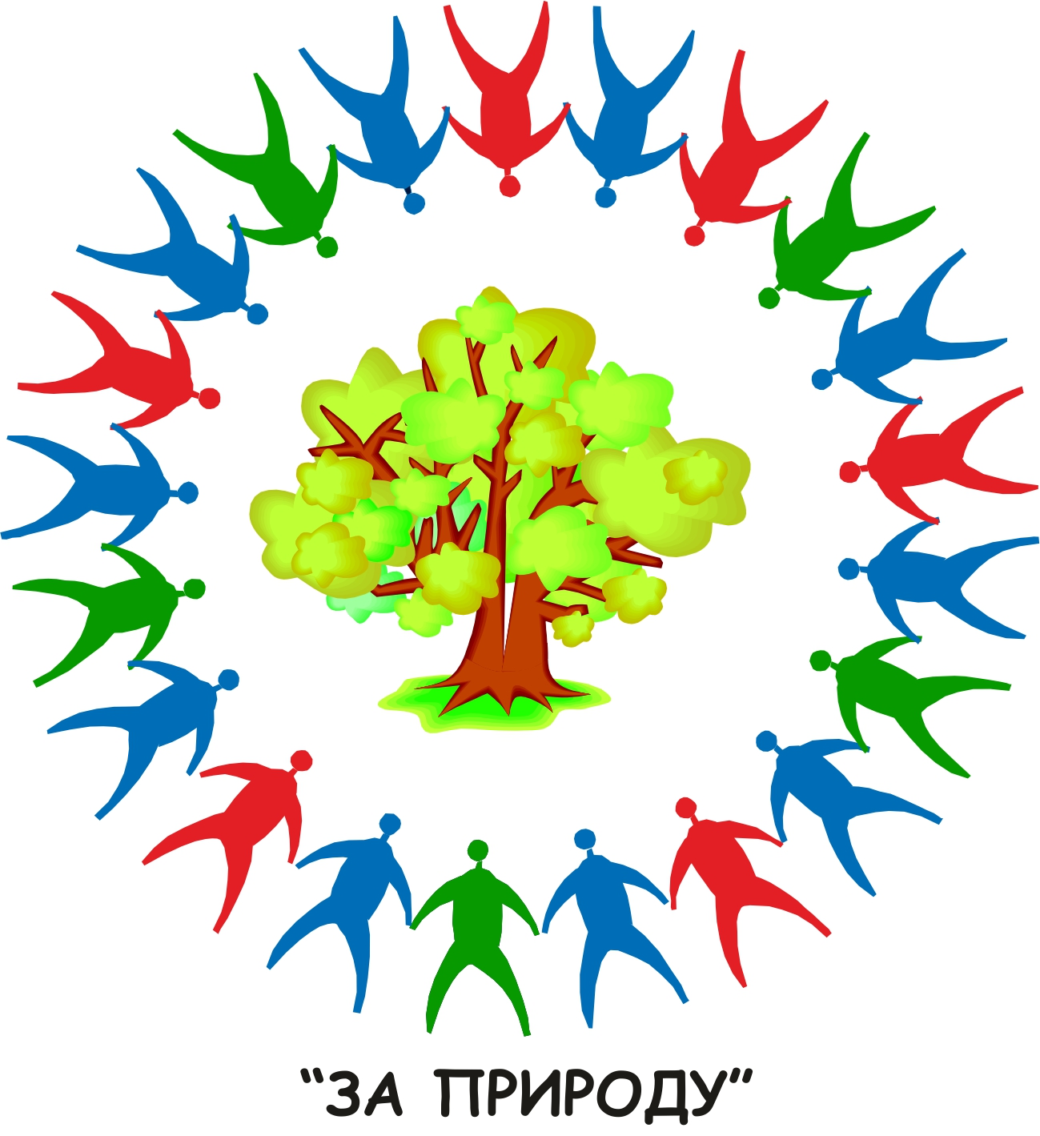

Joint Statement of U.S. - Russian
Non-Governmental Organizations, Movements and Campaigns

World Conference Against Atomic & Hydrogen Bombs
Hiroshima – August 2 - 9, 2019

74 years have passed since the atomic bombings of Hiroshima and Nagasaki. These indiscriminate and terrorizing bombings were designed to extend U.S. power in Asia, and to introduce nuclear blackmail as a new political tool at the dawn of the Cold War. The United States, Russia, Britain, France and China spent approximately $10 trillion dollars to develop national nuclear programs. This is comparable to the annual budget of all the rest of the world’s militaries for decades.

Today the United States and Russia are the main nuclear opponents, possessing 90% of the world’s atomic weapons, with Israel, India, Pakistan and North Korea also having become nuclear weapons states with near omnicidal power.

Since the A-bombings of Hiroshima and Nagasaki, continued preparations for nuclear war, the practice of nuclear blackmail, and numerous miscalculations and nuclear weapons accidents have brought humanity to the brink of nuclear catastrophe. As many of our leaders and experts have testified, such disasters have been avoided as a consequence of luck and by wise and courageous individual acts.

Luck is an extraordinary slender reed on which to base human survival. We must heed of the Hibakusha’s warning that “human beings and nuclear weapons cannot coexist”, and build from the wisdom of the Russell-Einstein manifesto that if nuclear catastrophe is to be avoided we must “remember our humanity and forget the rest.”

We welcome the pressure that many of the world’s nations are applying to the nuclear powers with the negotiation, signings and ratifications of the Nuclear Weapons Prohibition Treaty. We also welcome U.S. and Russian civil society initiatives for renewed great power détente, common security policies, and efforts to reverse what threatens to become an unbridled 21st century nuclear arms race and global efforts to address and reverse climate change.

The period following the Post-Cold War era is marked by uncertainty and existential dangers, namely: tensions between rising and declining powers, complex alliance structures, intense nationalism, territorial disputes, arms races with new technologies, economic integration and competition, wild card actors, and the disastrous impacts of climate change.

In these contexts we decry the dangerous and unacceptable nuclear threats made in recent years by each of our governments. In Russia’s case we are referring to Crimea, and in the U.S. we are referring to Iran and Korea.

More, the Bulletin of the Atomic Scientists’ Doomsday Clock has been set at two minutes to midnight. We face the impending collapse of the world’s fragile arms control architecture built over five decades. The reiteration of U.S. and Russian first strike nuclear war doctrines, commitments by each of these nuclear powers to upgrade and increase their reliance on their nuclear arsenals, tensions and provocative military exercises from the Baltic to the Black Seas, and the development and deployment of cyber warfare capabilities which can function as new weapons of mass destruction all increase the existential danger facing humanity.

The severity of the crisis is real. It is compounded by the growing tensions between the U.S. and China, making it imperative that civil society and conscientious governmental officials take urgent actions to inspire a new era of great power détente, reverse their increasingly dangerous arms races, and make credible steps toward finally fulfilling their Article VI Nuclear Non Proliferation Treaty obligations and the 1996 International Court of Justice opinion on the use and threatened use of nuclear weapons.

We note, as well, the increasing dangers of nuclear war being sparked by Indian-Pakistani tensions and nuclear war preparations, the growing dangers of regional war resulting from the U.S. violation of the Joint Comprehensive Plan of Action agreement with Iran, the unresolved confrontation over North Korea’s nuclear weapons program, and U.S.-Chinese confrontations in the South China Sea.

History teaches that with the development of countervailing political, diplomatic and popular power nuclear disarmament and the creation of a nuclear weapons-free world are possible. Respect for truth, freedom of speech and assembly, democratic institutions and the rule of law are essential for the mobilization of popular will and thus to achieve the complete elimination of the world’s nuclear arsenals. We therefore urge civil society organizations and government officials to work to:

- Halt all spending, development and deployment of all new nuclear weapons and their delivery systems, with financial savings devoted to addressing urgent human needs--including green infrastructure development.
- Eliminate first strike nuclear war fighting doctrines, retire and destroy of all nuclear first strike nuclear weapons.
- Create a joint statement by the presidents of Russia and the United States that a nuclear war cannot be won and must never be fought.
- Renew commitments to the CFE and INF Treaties and extend the New START Treaty.
- Begin negotiations, including China, to advance nuclear disarmament, to completely ban weapons from space and to eliminate the dangers of cyber warfare.
- Convene the long-promised conference for the creation of a Middle East Nuclear Weapons-Free Zone.
- Pursue multilateral negotiations for a Northeast Asian Nuclear Weapons-Free Zone.
- Defend the JCPOA and prevent a U.S.- Iranian war.
- Guarantee freedom of speech and assembly, respect for intellectual integrity and democratic processes.
- Recognize the interrelationship of climate change and nuclear weapons and take action to reverse these existential dangers.
- Facilitate the building of mutual understanding and trust among the U.S. and Russian peoples and governments – a prerequisite for fundamental policy changes – by facilitating people-to-people exchanges: cultural, scientific, academic, political exchanges and conventional tourism.

Joseph Gerson, Campaign for Peace Disarmament and Common Security, USA  Joseph Essertier, associate professor, Nagoya Institute of Technology, USA  Jun Hamamoto, Mindful Peace Building and San Quentin Origami, USA  Emily Rubino, Peace Action New York State, USA | Oleg Bodrov, Public Council of the Gulf of Finland, Russia  Nadezhda Kutepova, NGO The Planet of Hopes, Russia  Andrey Talevlin, For Nature, public movement, Russia  Svyatoslav Zabelin, International Socio-Ecological Union

